**Practice project assisted**

Create an HTML file to initiate a servlet

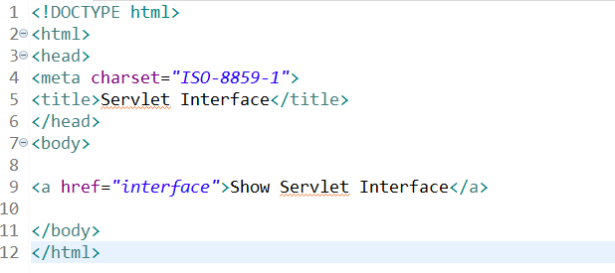

Create a servlet that implements the servlet interface

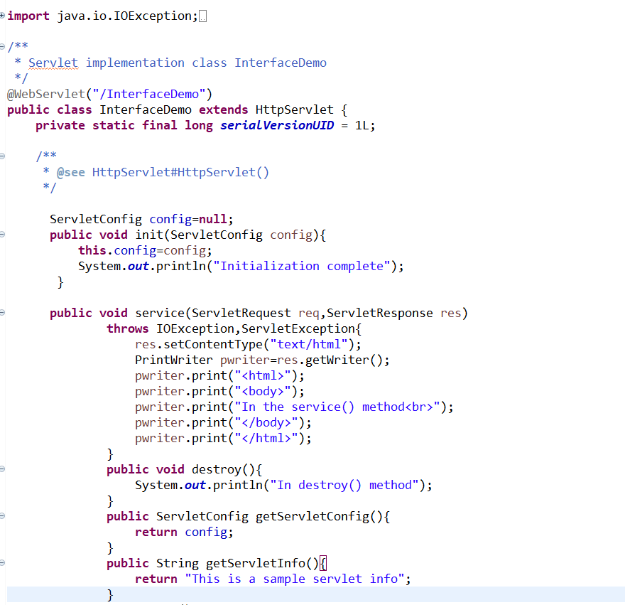

Web.xml

